**Nikita Eliseev**

**Profile**

Very passionate about making sure my clients know what they need in a hyper-connected world that is always rapidly evolving.

My work give me the opportunity of tackle diverse challenges and projects and solidify my reputation as a talented Full stack Engineer who was doggedly committed to providing each client with cutting edge solutions to take their online presence to the highest level.

**WEB SKILL**

Front End

ReactJS | VueJS | AngularJS | BackboneJS | Bootstrap | EmberJS | Next.JS | MEAN.JS

Back End

Ruby on Rails | Django | ASP.NET | Laravel | ExpressJS | Magento | CakePHP | Yii | CodeIgniter

Javascript Technology

Electron | BabylonJS | D3.JS

Database Technology

PostgreSQL | Mysql | Mongodb | Oracle

**MOBILE SKILL**

iOS | Android | Ionic | Flutter | React Native

**TREND SKILL**

Blockchain | Ethereum | Bitcoin | Smart Contract | AI

**Career and Qualification   
New Vison Systems Inc. 2010 - 2014.**

|  |  |  |  |
| --- | --- | --- | --- |
| **Degree/Diploma/Certifications** | **Duration/Period** | **Grade/%age** | **University/Institution** |
| Bachelor of Science(Computers) | 2010-2014 | 100 | Murmanskij Gosudarstvennyj Tehniceskij Universitet, Russian Federation |

**Personal Details**

**Health:** Excellent;

**Interests:** Sport, Singing  
  
**My Past projects:**

**PROJECT :** [Store location across country with operations hours](javascript:)

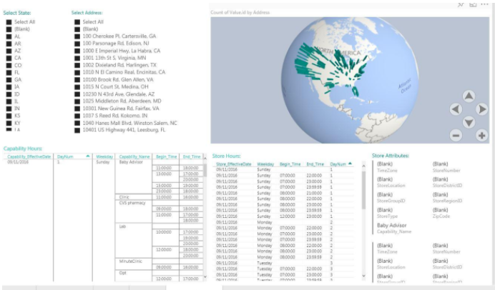This specific data visualization created to show the foot print of brand across United states with various data elements in dashboard.

## PROJECT : Built an real estate portfolio for home mortgage

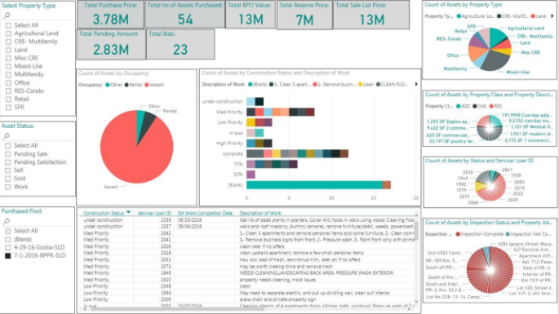

Provided one stop to go solution using Power BI with integrating Sales force data and on premise excel data integration with Power BI real time analysis and implementing KPI's.

**Contact Information:**

Mail: [yeliseev.n83@mail.ru](mailto:yeliseev.n83@mail.ru)

Skype: live:.cid.b3cea75bc25caa70

Nikita Eliseev